**Library Inventory System**

<https://github.com/Isomorphismss/CSCI-UA-470-Final-Project>

Group# OOP_Project 1

Student 1: Xuefeng Song (xs2039)

Student 2: Jiasheng Wang (jw6699)

Date of Submission: 12/14/2023

**Table of Work**

(Please write x in the boxes to mention what each student achieved in this project)

|  |  |  |
| --- | --- | --- |
|  | Student-1 Name | Student-2 Name |
| Project Description | x | x |
| Uses Cases Diagram(s) | x | x |
| Sequence Diagrams | x | x |
| Class diagram(s) | x | x |
| Implementation | x | x |
| Conclusion | x | x |

Table of Contents

* System Analysis
  + Project Description (One Page)
    - General Description, Goals and Benefits
    - System input(s) and output(s)
  + Uses Cases Diagram(s) and use cases description.
* System Design
  + Sequence Diagrams
  + Class diagram(s)
* Conclusion

**System Analysis**

**Project Description**

* **General Description:** Our Library Inventory System is an intuitive and efficient platform designed to enhance book management and accessibility. It offers a range of functions, including the ability to add, search, lend, and browse books, as well as update book information, delete entries, view all lent books, and return books. The system is crafted with the goal of providing a user-friendly and convenient service for book management, a feature relatively rare in the current market. It has a well-organized structure and an easy-to-navigate interface, ensuring a comfortable experience for users.
* **System input(s) and output(s):**
  + - Adding a Book: Users input details such as the title, author, ISBN, genre, and quantity.
    - Searching for a Book: Inputs include search queries like title, author, ISBN, and genre, with the output being a list of books matching these criteria.
    - Lending a Book: The input required is the borrower's name and the due date.
    - Browsing All Books: The output is a comprehensive list of all books available in the library.
    - Updating Book Information: Users input the updated details of a selected book, with the output being an updated list of books.
    - Deleting a Book: The output is the updated list of available books post-deletion.
    - Viewing Lent Books: The output includes information on all currently lent books.
    - Returning a Book: The output is the updated list of lent books after the return.

**Use case diagrams and descriptions**

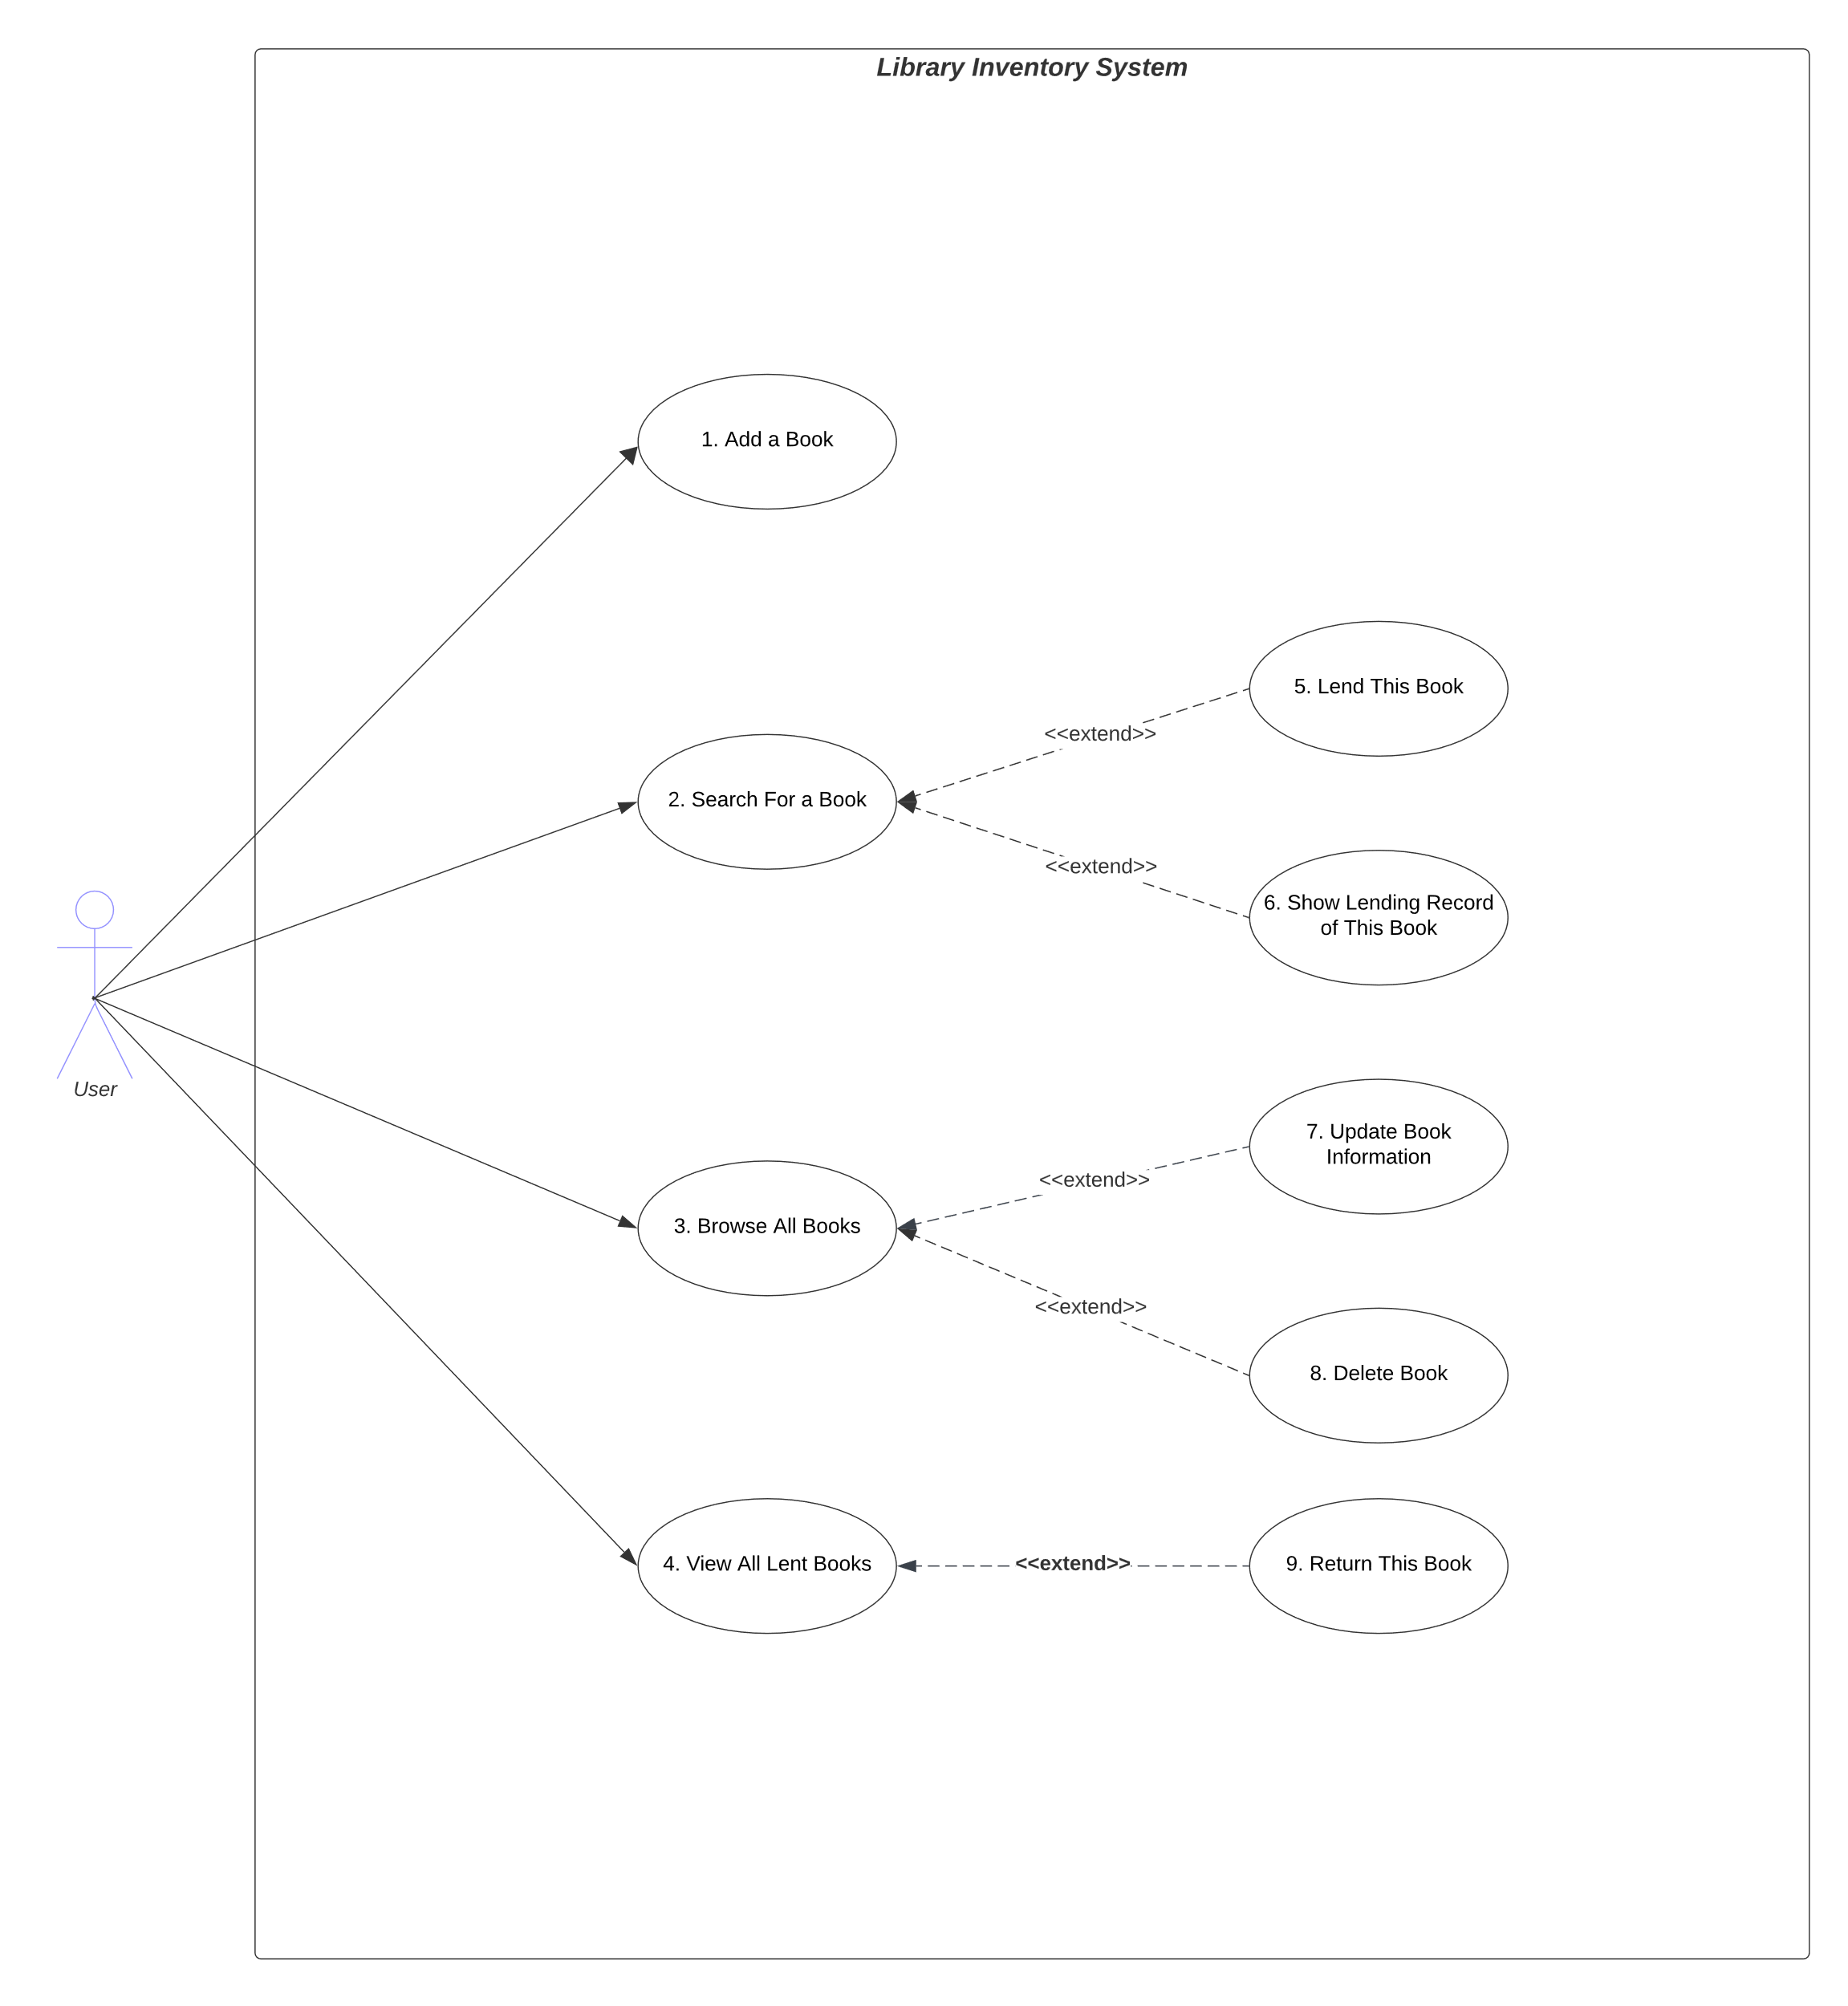

|  |  |
| --- | --- |
| **UC Reference Name/Number** | Add a Book (UC1) |
| **Overview** | Users can add a new book to the library inventory system, including information about title, author, ISBN, genre, and quantity. |
| **Related use cases** | N/A |
| **Actors** | User |

|  |  |
| --- | --- |
| **UC Reference Name/Number** | Search For a Book (UC2) |
| **Overview** | The user can search the book in the library inventory system by title, author, ISBN, and genre. |
| **Related use cases** | Lend this book (UC5), show lending record of this book (UC6) |
| **Actors** | User |

|  |  |
| --- | --- |
| **UC Reference Name/Number** | Browse All Books (UC3) |
| **Overview** | Users can view all their added books’ details stored in the library inventory system. |
| **Related use cases** | Update Book information (UC7), Delete Books (UC8) |
| **Actors** | User |

|  |  |
| --- | --- |
| **UC Reference Name/Number** | View All Lent Books (UC4) |
| **Overview** | Users can view all the lent books’ details stored in the library inventory system |
| **Related use cases** | Return this book (UC9) |
| **Actors** | User |

|  |  |
| --- | --- |
| **UC Reference Name/Number** | Lend This Book (UC5) |
| **Overview** | Users can lend a book from the library inventory system |
| **Related use cases** | Search for a Book (UC2) |
| **Actors** | User |

|  |  |
| --- | --- |
| **UC Reference Name/Number** | Show Lending Record of This Book (UC6) |
| **Overview** | Users can show the lending record of a specific book from the library inventory system |
| **Related use cases** | Search For a Book (UC2) |
| **Actors** | User |

|  |  |
| --- | --- |
| **UC Reference Name/Number** | Update Book information (UC7) |
| **Overview** | Users can update the information (title, author, ISBN, genre, and quantity) of the selected book |
| **Related use cases** | Browse All Books (UC3) |
| **Actors** | User |

|  |  |
| --- | --- |
| **UC Reference Name/Number** | Delete a Book (UC8) |
| **Overview** | Users can delete a book from the library inventory system |
| **Related use cases** | Browse All Books (UC3) |
| **Actors** | User |

|  |  |
| --- | --- |
| **UC Reference Name/Number** | Return This Book (UC9) |
| **Overview** | Users can return a book to the library inventory system, and then this book are able to be borrowed again |
| **Related use cases** | View All Lent Books (UC4) |
| **Actors** | User |

**Class Diagram**

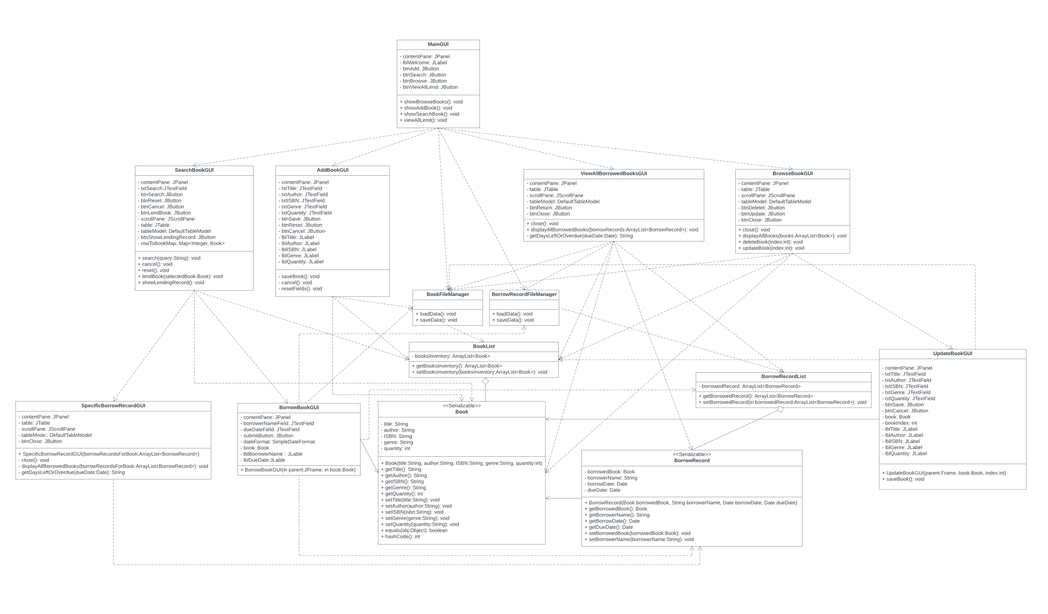

**Conclusion:** Our Library Inventory System is a simple yet effective solution for basic library management needs. Moving forward, we are committed to enhancing its capabilities, aiming to develop a comprehensive Library Inventory System that incorporates a variety of advanced functionalities.